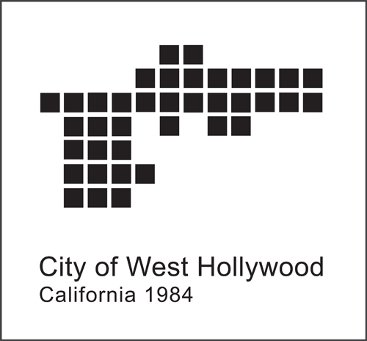

CITY OF WEST HOLLYWOOD
NOTICE OF CONTINUANCE

PUBLIC HEARING:

3.A. CONTINUE TO A DATE UNCERTAIN THE PROPOSED ORDINANCE AMENDMENTS TO THE WEST HOLLYWOOD MUNICIPAL CODE PROHIBITING SMOKING IN ENCLOSED COMMON AREAS AND NEW UNITS WITHIN MULTI-FAMILY DWELLINGS, CREATING A REGISTRATION PROGRAM THAT REQUIRES DESIGNATION OF UNITS’ SMOKING STATUS, AND PROHIBITING SMOKING IN ANY PARK OR WITHIN FIVE (5) FEET OF ANY PARKLET

NOTICE IS HEREBY GIVEN that the City Council of the City of West Hollywood at a regular meeting held on April 20, 2020 continued said public hearing to a date uncertain.

AFFIDAVIT OF POSTING
State of California )
County of Los Angeles )
City of West Hollywood )

I declare under penalty of perjury that I am employed by the City of West Hollywood in the Office of the City Clerk, and that I posted this notice on:

Date: April 21, 2020
Signature:\\Alyssa T. Poblador\\
Office of the City Clerk

