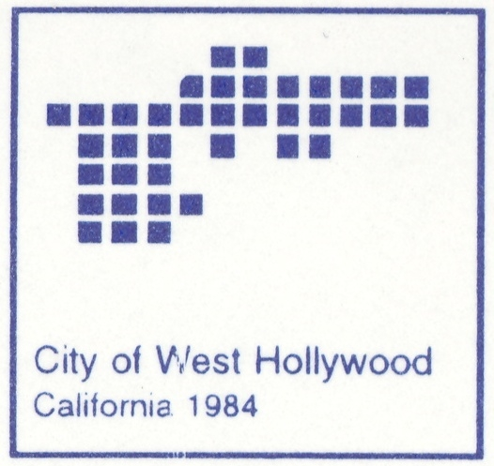
City of West Hollywood
2010 – 2012 Budget
Suggestions

The City of West Hollywood is preparing its 2010-2012 two-year operating budget and 2010-2015 five-year capital work plan. Please take this opportunity to be included in the City’s budget process by providing your input in the sections below. Your suggestions on issues and funding will be considered as the City develops its budget over the coming months.

Section I: Contact Information

Name:

Address:

City: Zip:

Phone #:

Email:

Section II: Suggestions

In developing the City’s budget and staff’s work plans for the coming years, our principal objective is to continue to move toward achieving the Five Primary Goals established in the Vision 2020 Strategic Plan. As West Hollywood turned 25, our major projects in the 2008-10 Budget included the 25th Anniversary Capital Project and the General Plan Update. As we begin the next 25 years, please tell us what issues are important to you as a constituent of the City.

1) What do you think are the most important issues facing West Hollywood in the coming years?

2) What programs or services do you think should be funded to address those issues?

Section III: Thoughts

Please give us your thoughts about the community, the people or the services the City provides. Let us know why you chose to live, work or play in West Hollywood. Please keep your responses to 75 words or less.

If selected for inclusion in the budget, do you want you thoughts posted anonymously? Yes No

Please mail or return completed forms to:

City of West Hollywood
Attn: Budget & Compensation Division
8300 Santa Monica Boulevard
West Hollywood, CA 90069

For questions or more information, please contact the City of West Hollywood, Budget and Compensation Division at (323) 848-6524. Thank you for your time and participation!

