NOTICE OF CANCELLATION

NOTICE IS HEREBY GIVEN that the meeting of the Performing Arts and Cultural Affairs Subcommittee of the Arts and Cultural Affairs Commission scheduled for Thursday, April 9, 2020, at 5:00 p.m. has been cancelled.

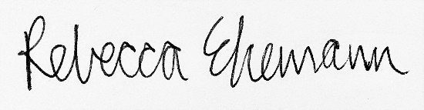
Rebecca Ehemann
Acting Arts Manager
Arts and Cultural Affairs Commission
AFFIDAVIT OF POSTING

State of California )
County of Los Angeles )
City of West Hollywood )

I declare under penalty of perjury that I am employed
by the City of West Hollywood in the Office of the
City Clerk, and that I posted this agenda on:

Date: April 6, 2020
Signature:\\Alyssa T. Poblador\\
Office of the City Clerk

