REQUEST FOR QUALIFICATIONS

PROFESSIONAL

WEB DEVELOPER

(Deadline to submit: 12/31/2019)

CITY OF WEST HOLLYWOOD



Date Issued: May 1, 2019

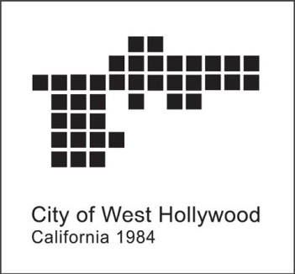

PROFESSIONAL WEB DEVELOPER SERVICES — PROJECT DESCRIPTION

From time to time, the City of West Hollywood requires highly qualified and experienced web development services for micro-sites supporting a wide array of City projects, initiatives, and programs. The City is currently gathering qualifications from interested web development professionals to establish a pool of individuals who can provide such services to the City on an as-needed basis.

ELIGIBILITY

This Request for Qualifications is open to experienced and professional web developers with demonstrated training and experience in web development, design services, and on-going website maintenance.

SELECTION PROCESS  
  
City of West Hollywood Communications Department staff will convene a minimum of three times on a regular basis and as needed to review submissions through this Request for Qualifications period.

The City’s Communications Department serves as the office of primary responsibility for day-to-day hiring and management of web developers.. All websites submitted will be subject to editing and production notes by the City’s Communications Department.

SCHEDULE + BUDGET

Should prospective web development professionals be considered for project(s), the City will issue a contract for services and on-going website maintenance. The issuance of a contract is not a guarantee of work. Following the establishment of a contract, project(s) may be assigned on an as-needed basis and each project will require an approved scope of work with estimated hours, rate/fee, not-to-exceed amount, and a purchase order issued by the City’s Finance Department before work may begin. The consultant will be required to have and maintain general liability and auto insurance for the contract period to meet the minimum requirements established by the City. Prior to commencing work, the consultant must attend an orientation with Communications Department staff.



CITY OF WEST HOLLYWOOD

The City of West Hollywood is like no other city in the world.

Located in the heart of metropolitan Los Angeles, the City was incorporated in 1984 by a unique collaboration of people including LGBT activists and advocates for affordable housing. At only 1.9 square miles, West Hollywood is a robust economic and cultural center instilled with idealism, creativity, and innovation. A spirit of community activism and civic pride thrives in West Hollywood for many of its approximately 35,000 residents.

The city has a strong progressive political voice and is filled with rich history. Tourists from all over the globe visit West Hollywood for its iconic destinations such as The Sunset Strip and historic Route 66. The city’s thriving creative and entertainment communities set trends in design, dining, music, fashion, art, and architecture.

Check out more at **www.weho.org** and follow **@wehocity** on social media.

TO APPLY

Applications must be submitted online: <https://form.jotform.com/82875291372162>

*The application will require the following information.  
Please read all of the information listed carefully.  
This is a request for qualifications and NOT a solicitation for proposals.  
Incomplete applications will be disqualified from consideration.*

1. GENERAL CONTACT INFORMATION

Name, Address, Phone, Email

Website, Instagram, Twitter (if applicable)

Type of consulting service

1. HOURLY RATE and/or FEE SCHEDULE
2. CV/RESUME (four page maximum)
3. WORK SAMPLES (PDF with examples or Link/URL)
4. REFERENCES

Provide phone and email references for at least three (3) references  
who can speak to their experience working with you on projects  
completed within the past five (5) years.

# QUESTIONS

For all questions related to this Request for Qualifications, please contact  
**Joshua Schare**, Communications Manager, at **(323) 848-6431** or at **jschare@weho.org**.

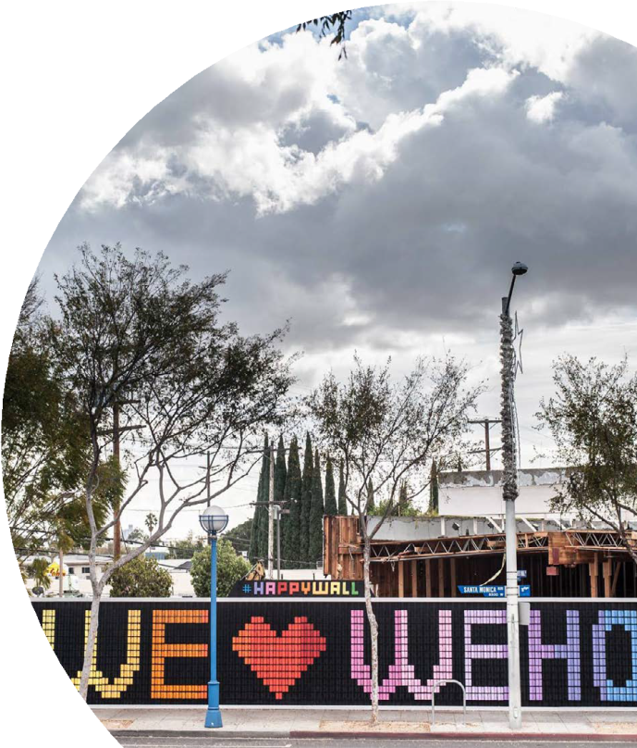The City of West Hollywood reserves the right to cancel or postpone  
this Request for Qualifications at any time.

