Arts Participation Grants support arts projects developed by educational, social service, or community-based organizations in which art is not the primary mission of the organization or art projects developed by nonprofit arts organizations whose annual budget is less than $25,000.00. The maximum award any organization may receive under this grant is $1,000.
Arts Participation Grants may be applied for at any time during the year
and will be awarded until funds are no longer available.

Please contact the program staff before beginning an application
to determine eligibility and available funding at pbonds@weho.org.

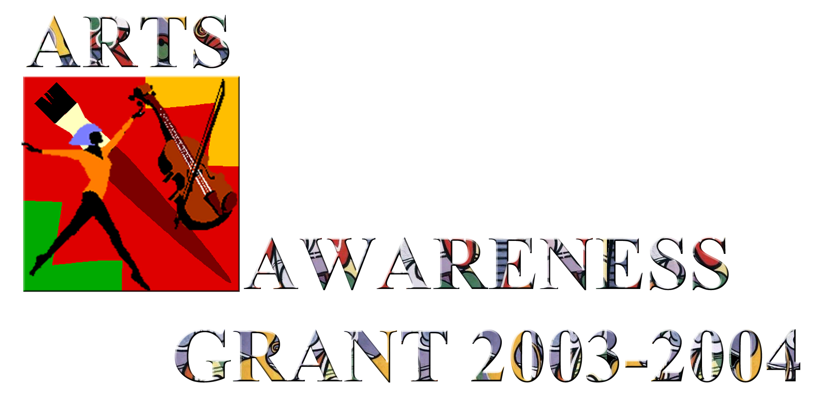

The City of West Hollywood, through its Arts and Cultural Affairs Commission, is pleased to offer year round Arts Participation Grants. These grants are:
- for small arts projects developed by educational, social service, or community-based organizations in which art is not the primary mission of the organization.
- for small productions or presentations of art projects developed by non-profit arts organizations whose annual budget is less than $25,000.00,
- especially suited to emerging arts organizations, educational, social service, or community-based organizations that want to undertake an arts education program for a specific population such as seniors, children, or special needs groups.
- meant to increase access to or participation in the arts and could be used for art making or arts participation activities, typically for educational or therapeutic purposes, in support of the organization’s mission.

The maximum award any organization may receive is $1,000.

General Eligibility Requirements

To be eligible for consideration, organizations must meet all of the following requirements:

- Organizations must be a registered nonprofit corporation;
- Organizations must be able to demonstrate significant commitment to and involvement with the West Hollywood community.
- Projects must take place in West Hollywood or in the immediate West Hollywood adjacent area and include West Hollywood residents in the proposed activities.

Review Process

Arts Participation Grants will be reviewed by the Arts and Cultural Affairs Commission on a case-by-case basis and as long as funding is available.

Applicants will submit an application and will be asked to present their request in person at a Performing Arts and Cultural Affairs Subcommittee meeting.

Applications will be reviewed with the following criteria: purpose of grant; audience served; organization’s involvement in and service to the West Hollywood community; ability to carry out the project and use the funds as awarded; alignment with the objectives of the Arts Participation Grant program.

Part 1: Organization Information

Please complete organization information:

Organization: |  | Date Established:

Address:

City, State, Zip:

Organization phone: |  | Organization fax:

Organization e-mail: |  | Organization website:

Organization director and title:
(All correspondence will be sent to this person)

Director phone: |  | Director e-mail:

Complete this section if different than above:

Preparer of the application and title:

Preparer phone: |  | Preparer e-mail:

Organization Budget: |  | Grant AmountRequest:

Check which discipline or category best describes your project. (Check one box only)

Arts Education  Dance  Literature/Poetry | Multi-disciplinary  Music  Theatre | Visual  Video/Film/Multi-media  Other ________________

CERTIFICATION
I, the undersigned, certify that all the information contained in this application is true, complete, and accurate. I have been authorized by my Board of Directors to submit this application to the West Hollywood Arts and Cultural Affairs Commission on its behalf. (Please sign in BLUE or BLACK ink.)

Signature: |  | Date:

Type name of signer and title:

Part II: Project Information

Please address the following questions in no more than two single-sided 8½ x 11” pages with 1” margins. Number each page and indicate the Applicant’s name in the upper right of each page. Applications must be typewritten, single-spaced in Arial font no smaller 11pt. Use the following headings and letters to organize your response:

- Organization Description: Provide a brief description of what the organization does (mission and primary programs).
- Details of the Project: Describe the project in detail. Provide a brief summary discussion of how the grant funds will be used. What is the amount requested? Who is the proposed or target audience? How many people will be served by this grant? Where will the activity take place? What is the time frame for starting and completing the project or program?
- Relationship with West Hollywood: Describe the organization’s relationship to West Hollywood and/or its communities.

Reminder: contact program staff before beginning an application to determine eligibility and available funding (323-848-6354 or 323-848-6883).
Please complete Parts I and II of the application, provide a copy of the organization’s most recent financial statement and submit these materials to:
Prentis Bonds
Secretary, Arts and Cultural Affairs Commission
8300 Santa Monica Boulevard
West Hollywood, CA 90069

Once the application and materials have been reviewed by staff, the organization will be scheduled for a presentation time with the Performing Arts and Cultural Affairs Subcommittee of the Arts and Cultural Affairs Commission.

